**To:** DOE Program Manager

**Re:** DOE MERP Proposal DE-FOA-0003256, AOI3a, University of Oklahoma; DOE Office of Fossil Energy and Carbon Management Funding Opportunity Announcement DE-FOA-0003256 AOI 1a & 1b

To Whom it May Concern:

Canadian Valley Technology Center does have potentially duplicative funding for the above-referenced grant. The potential overlap exists between this grant and the following grants:

**Grant Sponsor: Department of Energy**

**Grant #: Pending**

**Dates of Beginning and End of Grant: 1/1/2025 – 8/31/2028**

The training, development, and delivery for the “Methane Emissions Reduction Implementation Taskforce (MERIT)” to be created with DE-FOA-0003256 AOI 1a & 1b differs from the training, development, and delivery for the MERP Proposal DE-FOA-0003256, AOI3a. Therefore, the funding will not be used for duplicate purposes.

Sincerely,

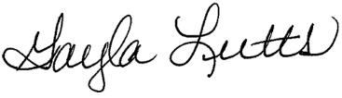

Dr. Gayla Lutts

Superintendent

glutts@cvtech.edu